Barony of Shieldwood
Ruler: Baron Arturo di Castellan
Area: 820 square miles
Population: 1,500 people
Castle Black-water: 130 people
Bywater Village: 70 People
Founded AC1015, The Barony of Shieldwood provides only a little (1/6th) of the firewood fuel needs of Specularum (Mirros) and it takes 106 riverboats per day to move that firewood down river to the capital all year round. The Baron has outlawed the clearing of land for farming to ensure that this Barony will be a major source of sustainable firewood for the good of the Kingdom. The Barony has Militia Service laws that require all farmers be proficient in crossbow. Currently the Barony is purchasing stone from a Quarry east of the Barony to construct a paved road.
The Villagers of By-Water has experienced good employment to move timber from the various woodlots to the docks. At Castle Blackwater

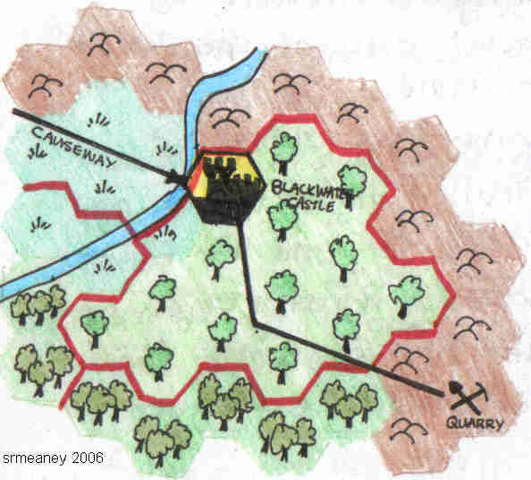

Baron Arturo di Castellan
Wizard level 17, Lawful (Good), 32HP, Abilities: S11, I18, W14, D12, C13, CH15 Skills: literacy (Thyatian), Literacy (Traladaran), Literacy (Darokinian), Literacy (Gnomish), Mathematica, Beekeeping, Leather working, Dancing (Traladaran), Ship Building, Pilot (small boats)
Weapon Mastery: Striking (Master)
Background: Karamekian Born (AC971). He adventured for a time gathering skill as a wizard before returning to Karameikos to find his Parents and sister dead at the hands of killers. Having finally brought them to justice after years of investigation, Arturo began advocating an end to the death penalty in favor of compulsory deportation. Eventually he was granted an estate and has worked hard to build it into a Barony. It is recently that he Married (AC1016) and now has a wife (Corrina Torenescu) and child (Isolde)
As a Baron he cares more for his populace than the foolish Barons around him. Baron Shieldwood is a Patron of Karamekian Artists and has several small galleries full of art. (He has a gallery containing portraits of every farming family in the Barony).
Personality: He is very much an outgoing individual who has come to enjoy the discovery of the new, despite the tragedy that afflicts his life.


Portrait of Arturo di Castellan, Baron of Shieldwood

Economy of the Barony

Resources: Wood & Timber
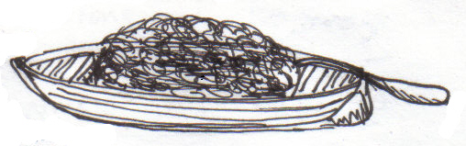
260 woodlots x 1700 acres each
260 x 17 acres x 20,000lb = 88,400,000lb

Production Yields (wood)
Farmers | 43,316,000lb
Baron | 30,940,000lb
Salt Tax | 8,840,000lb
Church Tithe | 5,304,000lb
Farmer | 166,600lb

Wood | Cord (8,000lb)
On the docks @ Mirros | 35gp
@ Castle Black-water | 21gp

Farm Income
Timber & Wood
(166,600/8000) x 21gp = 437.32gp/year
Monthly Farm Income | 36.44gp

Baron’s income
(30,940,000/8,000) x 21gp = 96,687.5gp

Baron’s Monthly Income | 8057.29gp

Budget (Annual)
50 Crossbowmen | 4,800gp
20 Light Horsemen | 4,800gp
Castle Staff | 3,960gp
Civil works: stone paved road  20’ wide, ½ mile long | 50,000gp
Farmers Festival Budget | 5,000gp
Education Budget | 2,000gp
Baron’s annual wage | 18,000gp

Important Dates in the Barony of Shieldwood

AC1020, Kladmont 28: Baron Castellan’s Day of Dread
Description: Gifts from Baron Kelvin arrive for the Baron’s wife and child. Soon after Lady Corrina Torenescu and daughter Isolde di Castellan fall ill and die. The Gifts are coated in a poison.
What is going on: Someone has sent gifts to the Baron and his family in the name of Baron Kelvin. They are poisoned and as magic has failed for the day, the clerics are unable to save their lives.

AC1021, Vatermont 17: Black Knight poisoned at Tournament
Description: The Barony hosts the annual Tournament this year. At the final set between a black Knight and a PC Knight, The Black Knight dies from poison. The Black Knight is revealed to be Baron Kelvin in disguise (hence his use of the non-lethal lance with the fist-end).
What is going on: Apparently someone decided to poison the most likely winner (The Black Knight). They bet twenty-thousand gold coins on the PC Knight to win (at odds of ten to one).
There will be rumors over this being linked to the death of Baron Castellan’s Family at the hands of Baron Kelvin and somehow the PC Knight will be implicated but never proven. The PC Knight will be frustrated in his/her attempts to gain an estate, titles, and will be treated with contempt and suspicion, etc.

AC1021, Thaumont 23: Baron and Guests Attacked by unidentified Wizard
Description: While at a dinner with his guests (Prince Valen amongst them), The dinner is interrupted when an unidentified Wizard gates in a Blackball, a Fire Giant with a pair of Hellhounds, and unleashes a furious attack on the Castle. After a battle which destroys part of the castle and a number of valuable portraits in the gallery, the attacking Wizard and Baron are locked in a savage hand to hand fight through the castle that takes them to the roof of the tallest tower where the Baron and his foe fall into the river Castellan and are lost.
What is going on: The PC Guests (and Prince Valen) are in a battle with the pets of some wizard who has picked this opportunity to attack the Baron. The Baron lost his family recently and exemplary management of the situation by a PC will put them in the running for a Barony (once Baron Castellan’s body is found down river).

Laws of the Barony
-King’s Law
-Clearing of Land for farming (Loss of Land rights, expulsion from the Barony),
-Failure to maintain working crossbow (Monetary fine: 10gp),
-Failure to be skilled in use of crossbow
(Monetary fine: 10gp & Compulsory militia training).

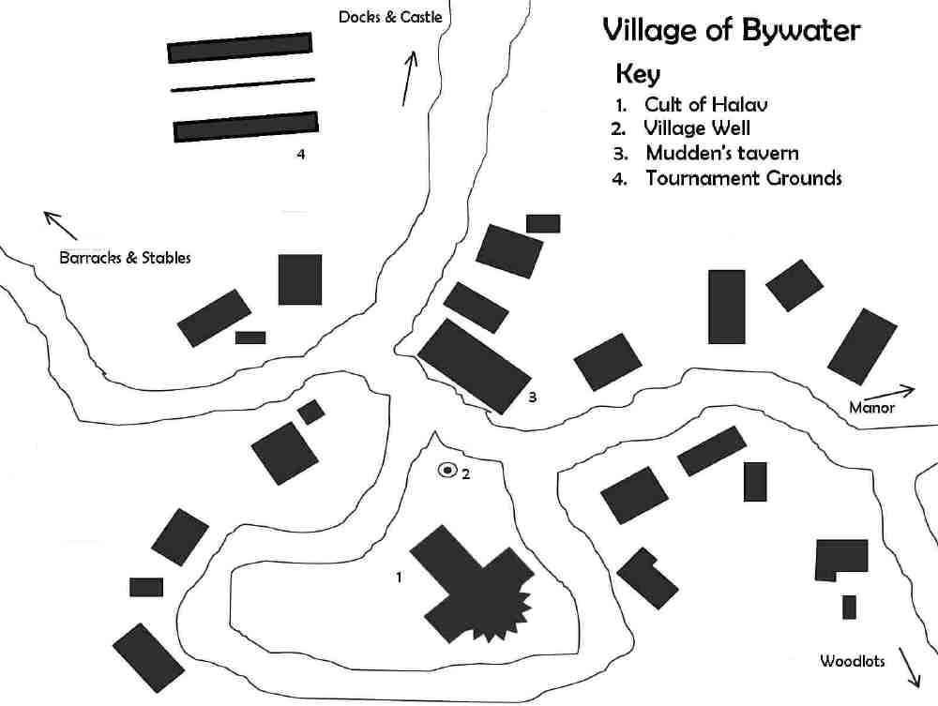
Key
1A-Storehouse
1B-Dock

Trade Docks
Key
20’ wide
1A
1B
Key
1A-Guest Manor
1B-Courtyard

Baron’s Manor
Key
20’ wide
1B
1A
Key
1A-Armory
1B-Stores
1C-Blacksmith
1D-Barracks
1E-Stables
Main Barracks
Key
20’ wide
1A
1B
1C
1D
1E
Key
7A-Tower Roof
Castle Level
7
Key
20’ wide
7A
Key
6A-Baron’s Laboratory
6B-Garterrobe
6C-Turret Access
6D-North-East Turret
6E-North-West Turret
6F-South-West Turret

Castle Level
6
Key
20’ wide
6A
5B
6B
6F
6E
6D

6C
Key
5A-Small Gallery
5B-Portrait Hall
5C-Garter Robe
5D-Roof-Access
5E-Childrens Room
5F-Baron
5G-Roof Walk
5H-Southwest Turret Access
5I-Northwest Turret Access
Castle Level
5
Key
20’ wide
5A

5B
5E
5F
5C
5D
5G
5H
5I
Key
4A-Small Gallery
4B-Guest Room
4C-Guest Room
4D-Guest Room
4E-Chapel Access
4F-Chapel
4G-Garter Robe
4H-Garter Robe
Castle Level
4
Key
20’ wide
4F
4A
4E
4G
4H
4D
4B
4C
Key
3A-Hall Balcony
3B-Access
3C-Small Hall
3D-Garter Robe
3E-Garter Robe
Castle Level
3
Key
20’ wide
3C
3A
3B
3D
3E
Key
2A-Great Hall
2B-East Access
2C-Buttery
2D-Pantry
2E-Kitchen
2F-Cellar Access
2G-Garter Robe
2H-Garter Robe
2I-Garden Access
2J-Main Access
2K-Balcony
2L-Garden wall
Castle Level
2
Key
20’ wide
Garden
2K
Dock
2F
2A
2B
F
F
2E
2C
2D
2H
2G
2J
2I
2L
River Castellan
Key
1A-Barracks
1B-Cellar
1C-Granary
1D-Garter Robe
1E-Garter Robe
1F-Garden
1G-Dock
Castle Level
1
Key
20’ wide
Garden
1G
1B
1A
C
C
1C
1D
1E
1F
River Castellan
Castle Builder
Name: Blackwater Castle & Surrounds
Castle Population Calculator
 |  | Servants
Lord/Lady | 2 | 2
Children | 3 | 3
Guests | 20 | 20
Soldiers | 70
smithy |  | 4
kitchen |  | 6
total servants |  | 35
total soldiers |  | 70
guests |  | 20
Lord/Lady |  | 2
children |  | 3
total population |  | 130
Castle Room |  | area (squ. ft.)
Lord&lady bedroom | 500
guest rooms | 6000
childrens room | 90
Barracks | 2090
great hall | 1750
chapel | 875
common hall | 2140
kitchen | 280
buttery | 93
pantry | 140
blacksmith | 500
armory | 167
stable | 7000
storehouse | 250
garder-robe | 11
cellar-15' high | 345
granary-15' high | 173
total square feet | 22403
Status | Baron | multiplier | 1.0
Title | multiplier
king | 3
duke | 3
marquis | 2
count | 2
baron | 1
knight | 0.5

