Fencing Weapons

I have created weapon mastery tables for two new types of daggers; the stiletto and the main-gauche.

Weapon | Level | Ranges | Damage | Defense | Special Effects
Stiletto | BS | 15/25/35 | 1d3 | - | -
[P=H] | EX | 20/30/40 | 1d4 | H:-1AC/1 | Stun (s)
 | SK | 25/35/50 | 1d4+2 | H:-2AC/2 | Stun (s)
Cost: 5gp | M | 30/40/60 | P=2d4  S=1d4+2 | H:-2AC/2 | Stun (s)  Double Damage (20)
Enc: 5cn | GM | 40/50/70 | P=3d4  S=2d4+1 | H:-3AC/3 | Stun (s)  Double Damage (19,20)

A stiletto possesses a long slender blade and needle-like point, intended primarily as a stabbing weapon. The stiletto blade's narrow cross-section and acuminated tip reduces friction upon entry, allowing the blade to penetrate deeply. Though similar to a dagger, stilettos are ineffectual at cutting or slashing.

A stiletto is very effective at penetrating armor thus granting a +1 bonus versus armored characters and monsters who receive a low AC due to the toughness of their hides. This bonus does not apply to characters without armor or monsters noted for their high dexterity.

Weapon | Level | Ranges | Damage | Defense | Special Effects
Main-Gauche | BS | - | 1d3 | - | No off-hand penalty
[P=H] | EX | 5/10/15 | 1d4 | H:-1AC/1 | No off-hand penalty  Disarm (Save)
 | SK | 10/15/30 | 1d4+2 | H:-2AC/2 | No off-hand penalty  Disarm (Save +2)
Cost: 5gp | M | 15/20/35 | P=2d4  S=1d4+2 | H:-3AC/3 | No off-hand penalty,  Disarm (Save +4)
Enc: 15cn | GM | 20/25/40 | P=3d4  S=2d4+1 | H:-4AC/4 | No off-hand penalty,  Disarm (Save +6)

The main-gauche (French for "left hand", pronounced: [mɛ̃ ɡoʃ]) is used mainly to assist in parrying incoming thrusts, while the dominant hand wields a rapier or similar longer weapon intended for one-handed use. It may also be used for attack if an opportunity arises. The Defense bonus offered by the Main-Gauche may be added to the Defense bonus provided by the weapon wielded in the primary hand.
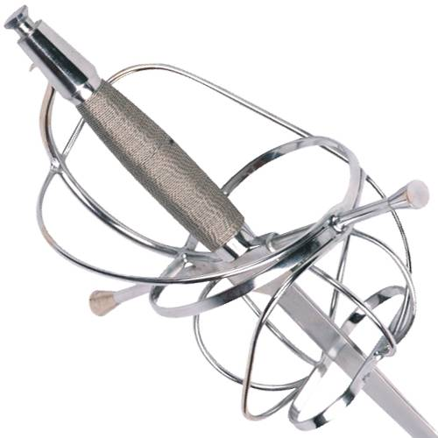

Weapon | Level | Ranges | Damage | Defense | Special Effects
Rapier | BS | - | 2d4-1 | -
[P=H] | EX | - | 1d8+1 | H:-2AC/2 | Deflect (1)  Disarm (Save)
 | SK | - /10/20 | P =1d8+2  S= 1d8+1 | H:-2AC/2 | Deflect (2)  Disarm (Save+2)
Cost: 10gp | M | - /15/25 | P=1d12  S=1d10 | H:-2AC/2 | Deflect (3)  Disarm (Save+4)
Enc: 60cn | GM | 10/20/30 | P=1d12+1  S=1d10+1 | H:-3AC/3 | Deflect (3)  Disarm (Save+4)

The shield negates the “Art of Fencing” required for the Rapier, negating all dense bonus and special effects. This weapon also suffers a -2 to hit versus suit armor.

A character may use buckler with a rapier.

Buckler Usage: This dexterity based general skill allows a character to employ a small shield called a buckler or target shield. The buckler has a 50 coin encumbrance and has a 10 coin encumbrance.
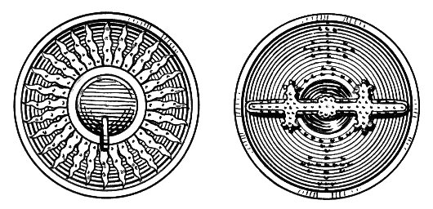
In use, the bearer of the buckler moves the target shield to intercept the melee blows of an opponent. The buckler, while effective in melee combat, is ineffectual against missile fire, providing no bonus to armor class.

Use of the buckler does not interfere with thief skills. For every round that this skill is being used, the character receives a +1 bonus to armor class against melee attacks. Mystics may not use the buckler. Magic-Users may use a buckler, but suffer the appropriate experience point penalty for using a shield.

