Ruins and dungeons
1
2
3
4
5
6

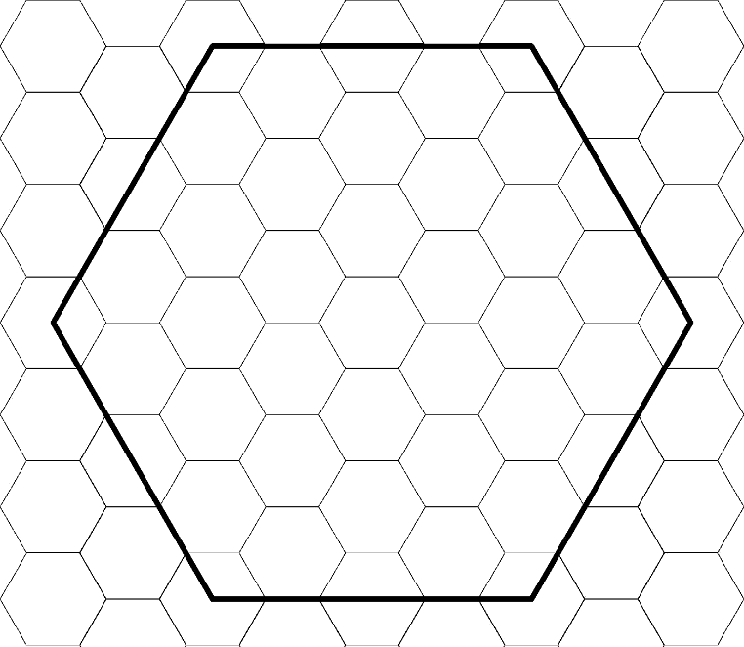
Scale
Large Hex = mile(s) Small Hex = mile(s)
Location:
Dominant environment
Main Population and density
Depth

Settlements (City to dwelling)
1
2
3
4
5
6
7
8
9
10

Monster Lairs
1
2
3
4
5
6
Other features
1
2
3
4
5
6
7
8

Encounter tables
Area: |  | Area: |  | Area:
1 |  | 1 |  | 1
2 |  | 2 |  | 2
4 |  | 4 |  | 4
5 |  | 5 |  | 5
6 |  | 6 |  | 6
7 |  | 7 |  | 7
8 |  | 8 |  | 8
9 |  | 9 |  | 9
10 |  | 10 |  | 10

Important NPCs
1 |  | 4
2 |  | 5
3 |  | 6
Local flavour:
1 |  | 4
2 |  | 5
3 |  | 6
Adventure seeds
1
2
3
4
5
6

N

